OODP HW3

21300691 WonSikCheung

User’s Manual

1. Compile java file
   1. > javac \*.java
2. Run AtmSimulator
   1. > java Main
3. Result

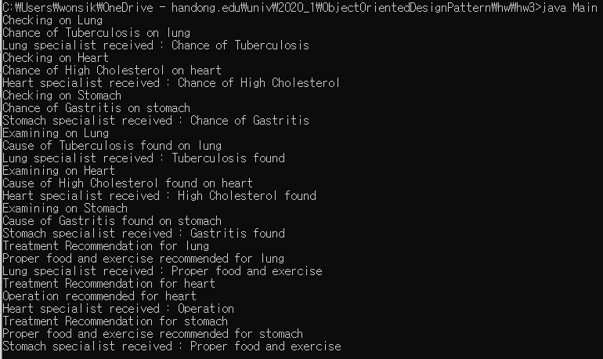

UML

